Manukau Outrigger Canoe Club 2024 Taitamariki/Intermediate Race Series
Sunday 28th April 2024
Ian Shaw Park Reserve, Mt Wellington
Pānui 1

EVENT SUMMARY
Manukau Outrigger Canoe Club welcomes you to the 2024 Taitamariki/Intermediate race series to be held at Ian Shaw Park Reserve Sunday 28th April 2024. Manukau Taitamariki/Intermediate Race Series is a series of races run throughout the winter season to allow the opportunity for our tamariki to continue to paddle throughout the winter months whilst keeping waka ama a sport of focus to choose and enjoy during the cooler months. This is to tautoko the inclusion of all abilities and fitness levels from our beginning junior paddlers to our more experienced junior paddlers. The event is a full day of fun racing, food vendors and an end of series prize giving.
We welcome you and your whānau to join us for this event.

EVENT SCHEDULE

9.00am | Registration & safety checks
9.10am | Karakia
9.15am | Managers meeting
9.30am | Race & safety briefings
10.00m | Racing starts
2.00pm | Racing finishes
2.15pm | Closing Karakia

RACE SCHEDULE

Time | Race
9.30am | Race Briefing - all races
10.00am | Race Start – W6 2km  Taitamariki
11.00am | Race Start – W6 4km Intermediate

RACE DAY INFORMATION
Car Parking: Parking is available inside the venue behind the Ngā Hau Maiangi building as well as street parking. Please note all parking is under Auckland Council management, you will need to read the signs and park accordingly. There is strictly NO parking past the island/roundabout.
Food: We encourage you to bring your own healthy kai.
Toilets: Toilets are located under the Ngā Hau Maiangi building.
First Aid: First Aid will be available at the registration tent.
Rubbish/Recycling: We encourage you to please take what you bring. However, there are council rubbish bins at the venue. Please note these are small bins only.
Alcohol/Smokefree: Alcohol, smoking, vaping and any other substance use is not permitted at this event, including all premises of the event.

WAKA DROP OFF & SAFETY CHECKS
Safety Checks:
- All waka will have to pass a safety check and be marked before racing. Any boats not marked
will not be permitted to race.

RACE RULES
All entrants must be familiar with the Waka Ama New Zealand race and safety rules.
Refer to the following link for more information: Waka Ama NZ Race Rules

AGE DIVISIONS & RACE EVENTS
WAKA | DISTANCE | DIVISIONS | GENDER
W6 | 2km | Taitamariki | Boys, Girls, Mixed
W6 | 4km | Intermediate | Boys, Girls, Mixed

FEES
Fees: Fees for this event are a gold coin koha per paddler. Pay at registration on the day.
PER PERSON BY AGE DIVISION
Age Division | Cost
Taitamariki | Gold coin koha per paddler
Intermediate | Gold coin koha per paddler

ONLINE ENTRIES & PAYMENT
- Online entries are to be completed using the Waka Ama NZ online entry system. https://www.wakaama.co.nz/racecalendar
- All entries to be completed through your club admin – contact your club admin to process your entry
- No entries on the day, no exceptions
- Entries close on Tuesday 23rd April 2023 11.59pm
- Rosters close on Wednesday 24th April 2023 11.59pm, rosters must be completed by close date, no exceptions.

SAFETY REQUIREMENTS
- All waka must be Safety Checked
- All taitamariki and intermediate age divisions must wear life jackets
- All Juniors must have the following safety equipment for their races:
  - PFD - Personal Floatation Device (per person)
  - Spare Paddle - 2 for a W6

INDIVIDUAL & TEAM WAIVERS
- Team waivers must be completed by all paddlers/teams
- All paddlers U18 must have their waiver signed by their parent/guardian
- Waivers can be sent to manukauoutriggers@gmail.com or handed in at the managers meeting on the day.
- Team waivers can be found here: Manukau Taitamariki/Intermediate Series: Race 1 (Subject to Sanctioning) - Waka Ama NZ
CONTACT INFORMATION
- All enquiries please email: manukauoutriggers@gmail.com
- All urgent matters please call: Heremaia Rosieur 0273208980

COURSE MAPS

2km Course
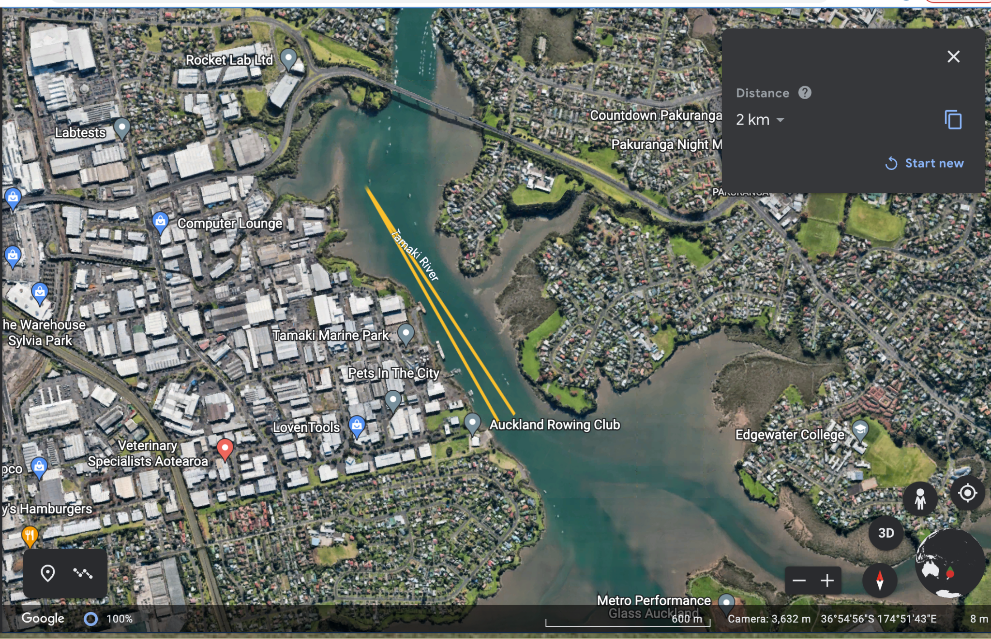

START/FINISH
TURN

4km Course
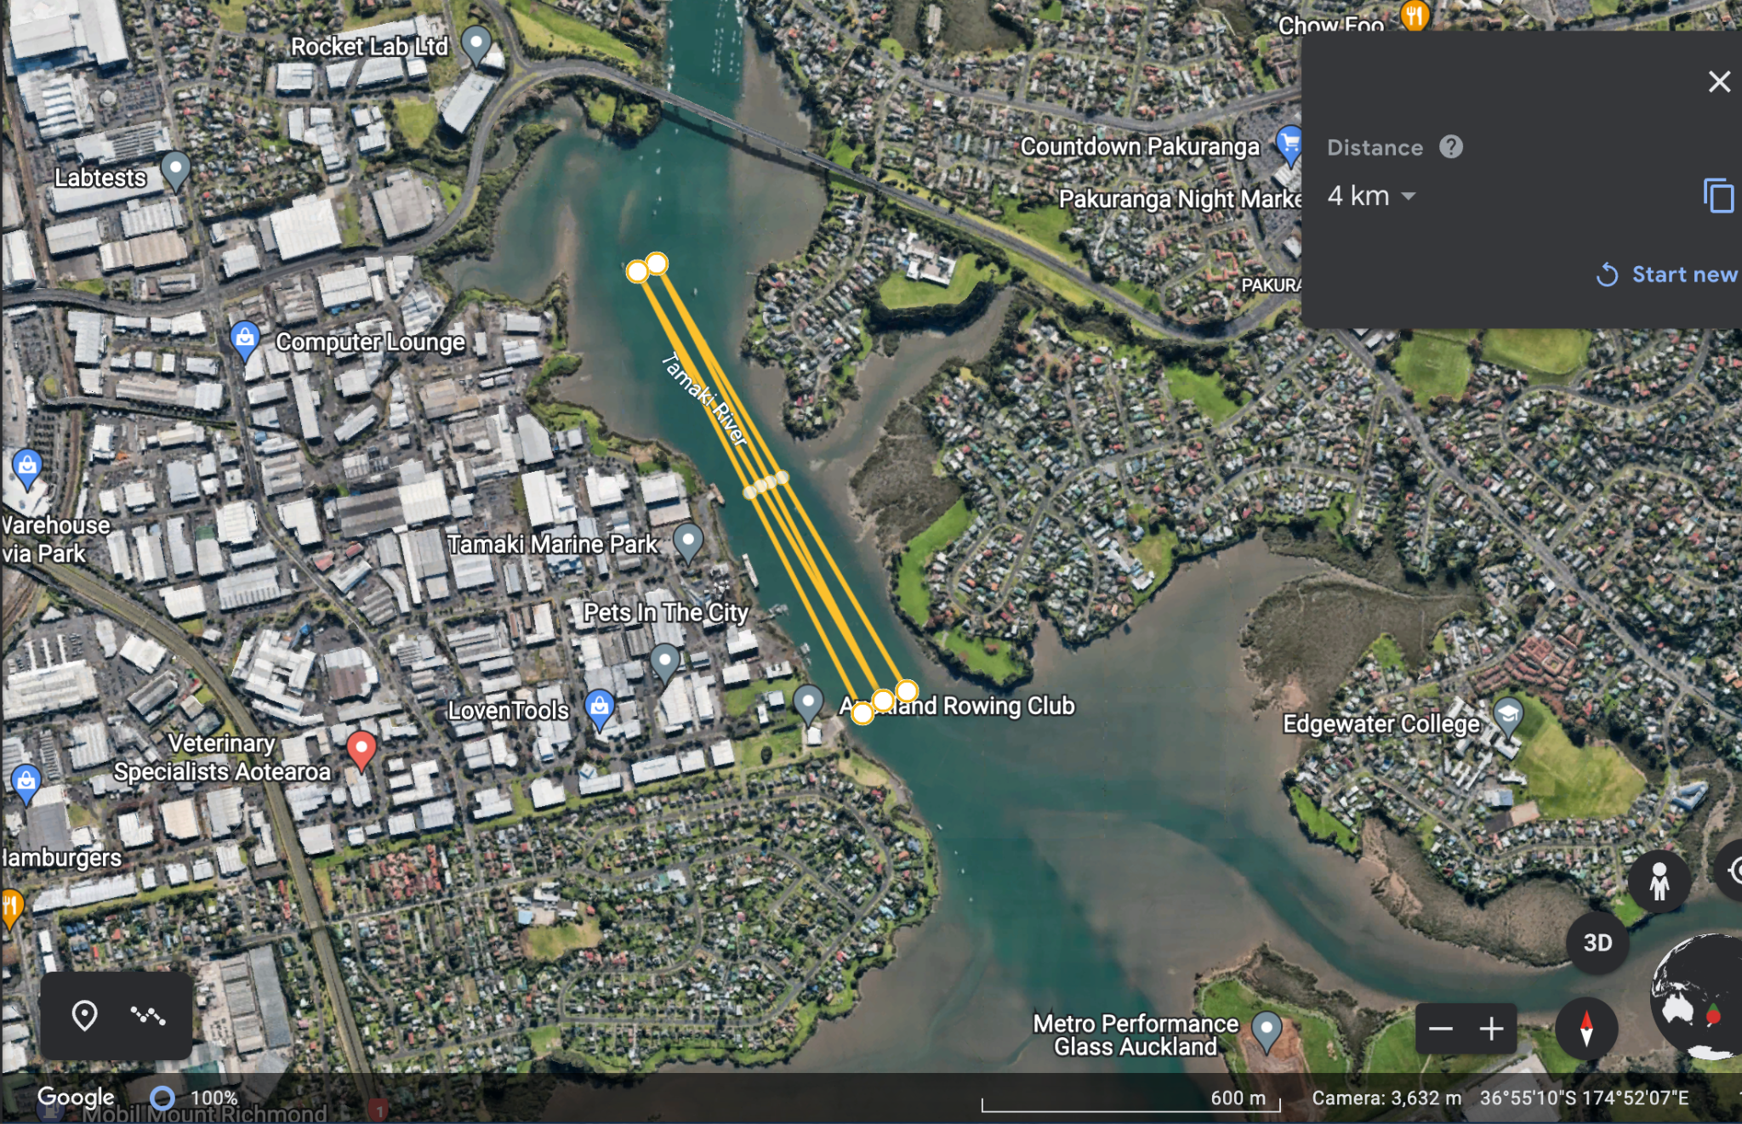

START/FINISH
TURN

- High tide: 10.19am
- Low tide: 4.14pm

